DESIGN THINKING
Design Thinking Mindset & Business Applications
1. DESIGN THINKING MINDSET
1.1 Meaning of Mindset
A mindset is a particular way of thinking, perceiving, and approaching problems. It influences how individuals interpret challenges, respond to uncertainty, and generate solutions. In Design Thinking, mindset is more important than tools or steps because it determines how problems are understood and solved.
1.2 Definition of Design Thinking Mindset
Design Thinking Mindset is a human-centered, creative, collaborative, and experimental approach to solving complex and ill-defined problems. It focuses on empathy, innovation, iteration, and learning through action.
1.3 Core Characteristics of Design Thinking Mindset
1. Human-Centered Thinking (Empathy): Understanding user needs, emotions, and pain points before designing solutions.
2. Curiosity and Questioning: Asking 'Why?' repeatedly and challenging assumptions.
3. Bias Toward Action: Preferring action and prototyping over excessive planning.
4. Comfort with Ambiguity: Accepting uncertainty and exploring multiple possibilities.
5. Iterative Thinking: Developing solutions through continuous improvement.
6. Collaboration: Working in multidisciplinary teams to generate diverse ideas.
7. Growth Mindset: Believing that creativity and problem-solving skills can be developed.
1.4 Importance of Empathy in Design Thinking
Empathy is the foundation of Design Thinking. It involves observing users, conducting interviews, and understanding their behavior to identify real problems rather than assumed problems.
1.5 Fixed Mindset vs Design Thinking Mindset
Fixed Mindset Characteristics:
- Avoids failure
- Prefers single correct answers
- Works in isolation
- Follows rigid procedures
Design Thinking Mindset Characteristics:
- Learns from failure
- Explores multiple solutions
- Encourages collaboration
- Emphasizes experimentation
1.6 Benefits of Design Thinking Mindset
• Enhances creativity and innovation
• Encourages risk-taking and experimentation
• Improves problem-solving skills
• Promotes user satisfaction
• Develops adaptability in dynamic environments
2. DESIGN THINKING BUSINESS APPLICATIONS
2.1 Need for Design Thinking in Business
Modern businesses operate in highly competitive and rapidly changing environments. Customer expectations are increasing, and traditional management approaches are often insufficient. Design Thinking helps organizations innovate by focusing on user experience and experimentation.
2.2 Key Areas of Application
1. Product Innovation: Developing new products or improving existing ones based on user insights.
2. Service Design: Enhancing service experiences in sectors like banking, healthcare, and hospitality.
3. Customer Experience (CX): Improving website design, mobile applications, and customer interaction systems.
4. Business Model Innovation: Creating new revenue models such as subscription-based services.
5. Social Innovation: Addressing societal challenges through user-centered public services.
6. Startup Development: Building Minimum Viable Products (MVPs) and validating ideas quickly.
2.3 Benefits of Design Thinking in Business
• Increased customer satisfaction
• Reduced financial risk through early prototyping
• Faster innovation cycles
• Strong competitive advantage
• Improved brand loyalty
2.4 Traditional Approach vs Design Thinking Approach
Traditional Approach:
- Focus on internal efficiency
- Large-scale launch without testing
- Risk avoidance
- Linear problem-solving
Design Thinking Approach:
- Focus on user needs
- Prototype and test before scaling
- Learn from failure
- Iterative and flexible process
2.5 Example Case Study: Redesigning a College Canteen
Step 1: Empathize – Interview students and observe waiting times.
Step 2: Define – Identify key problem such as long queues.
Step 3: Ideate – Brainstorm solutions like token systems or mobile ordering.
Step 4: Prototype – Test a simple pilot system.
Step 5: Test – Collect feedback and improve.
3. Discussion Questions for Classroom
1. Why do some companies fail even with good technology?
2. Can Design Thinking be applied in government systems?
3. How does empathy improve engineering design?
4. Is failure necessary for innovation?
Conclusion
Design Thinking Mindset transforms the way individuals and organizations approach problem-solving. It shifts focus from products to people and from rigid planning to experimentation. In business, it drives innovation, improves customer satisfaction, and reduces risk through iterative development.

CASE STUDIES:

📘 CASE STUDY 1
Apple: Human-Centered Product Innovation
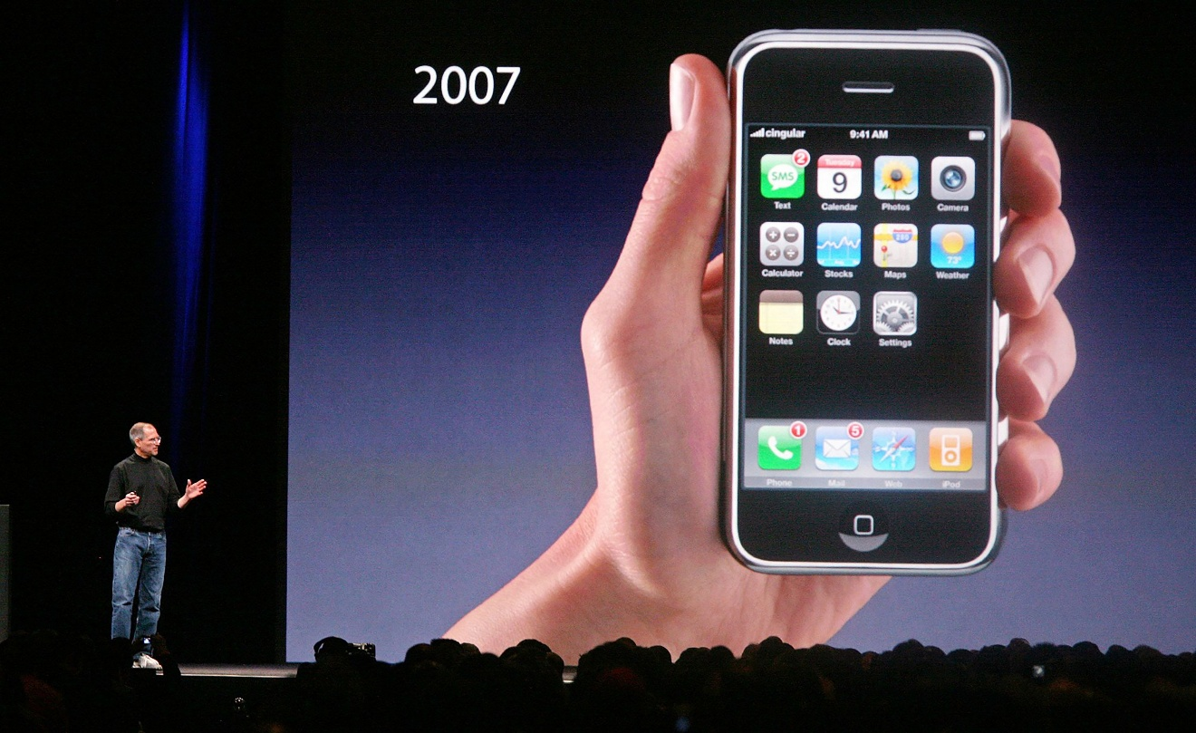
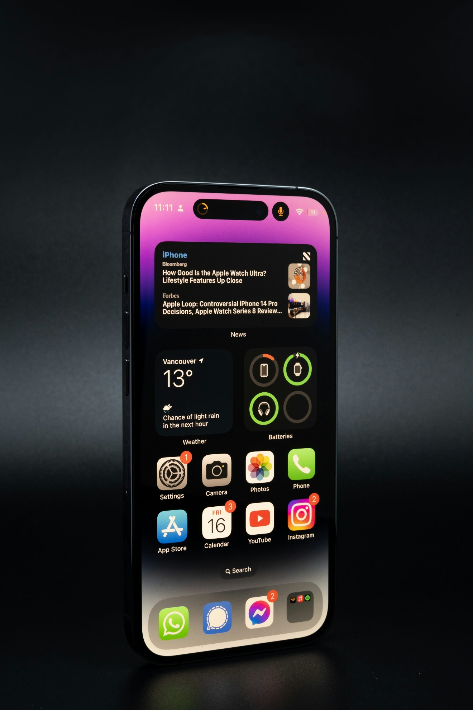
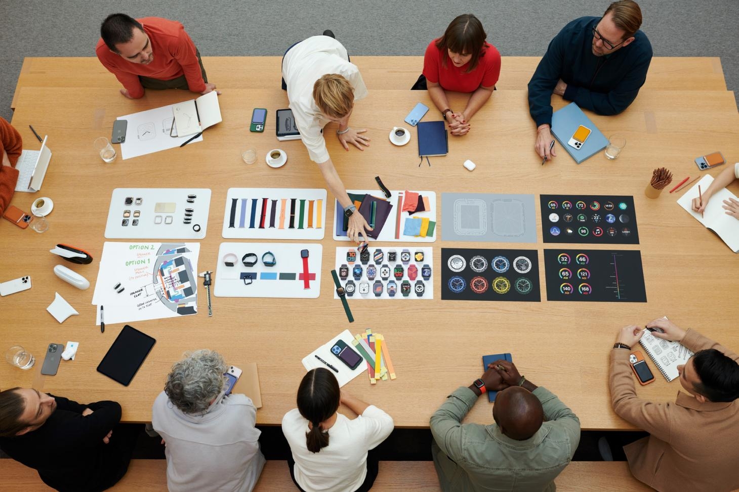
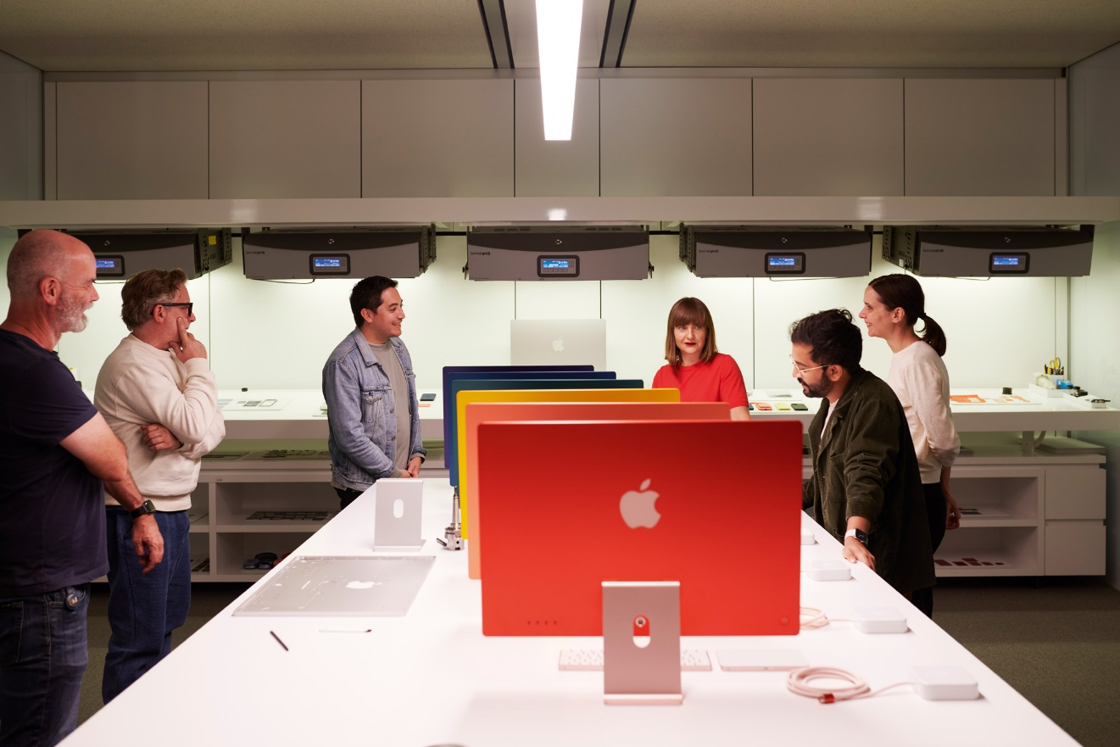
Background
Apple revolutionized the smartphone industry in 2007 with the iPhone.
Before iPhone:
- Phones had physical keyboards.
- Interfaces were complex.
- Internet browsing was poor.

The Core Problem
Consumers struggled with:
- Complicated buttons
- Small screens
- Poor user interface
- Non-intuitive navigation
Most companies focused on:
❌ Hardware features
❌ Technical specifications
Apple focused on:
✅ User experience

Design Thinking Approach
1️⃣ Empathize
- Observed how people used phones.
- Studied frustration with keypads.
- Noticed desire for simplicity.
2️⃣ Define
Problem statement:
"Users need a simple, intuitive device that integrates communication, internet, and entertainment seamlessly."
3️⃣ Ideate
Ideas generated:
- Touchscreen interface
- Gesture-based control
- Single home button
- App ecosystem
4️⃣ Prototype
- Built multiple touchscreen prototypes.
- Tested different screen sizes.
- Refined interface.
5️⃣ Test
- Usability testing.
- Iterative improvements.

Outcome
- iPhone became industry standard.
- Created app economy.
- Shifted entire smartphone market.

Discussion
- Did Apple invent the smartphone?
- What was the real innovation — technology or user experience?
- How did empathy drive success?

📘 CASE STUDY 2
Airbnb: Service Design & Trust Innovation
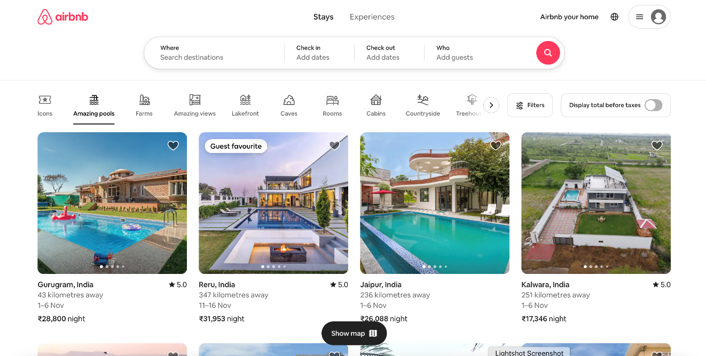


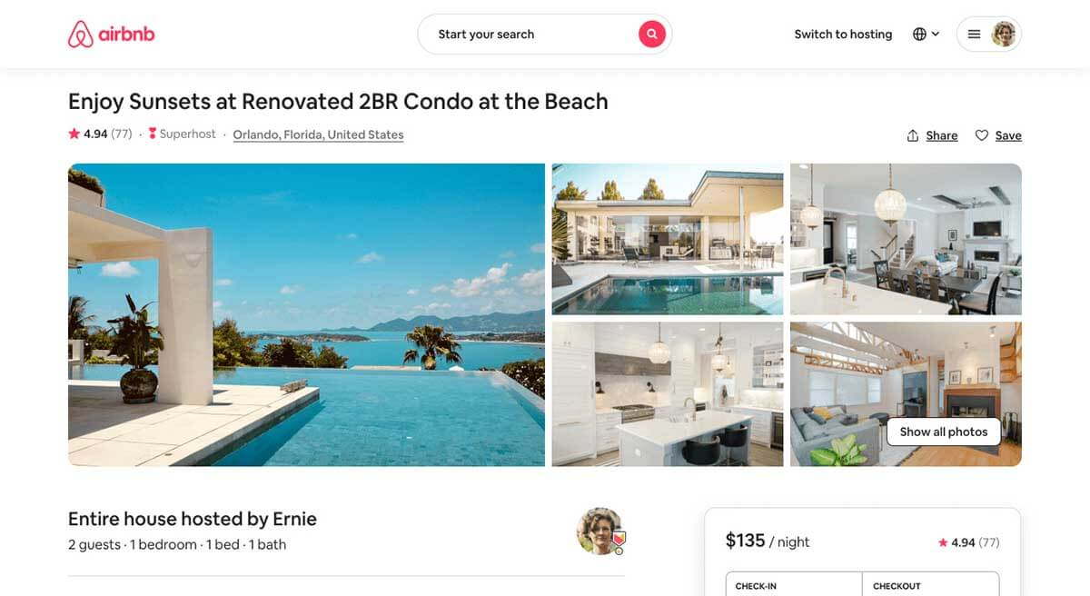
Background
Airbnb started in 2008.
Initial problem:
Nobody trusted strangers enough to stay in their homes.

The Core Problem
- Users hesitant to book.
- Low-quality photos.
- Lack of trust.
- Poor booking experience.
Revenue was falling.

Design Thinking Intervention
Empathize
Founders personally:
- Stayed with hosts.
- Talked to users.
- Observed booking process.
Define
Core issue:
“Trust deficit between hosts and guests.”
Ideate
- Professional photography
- Reviews system
- Secure payment
- Verified profiles
Prototype
Tested new listing photos in New York.
Test
Bookings increased dramatically.

Outcome
- Massive growth.
- Global platform.
- Trust became key differentiator.

Discussion
- What was Airbnb actually selling?
- Why did better photos increase revenue?
- How is trust a design element?

📘 CASE STUDY 3
GE Healthcare: Redesigning MRI Experience

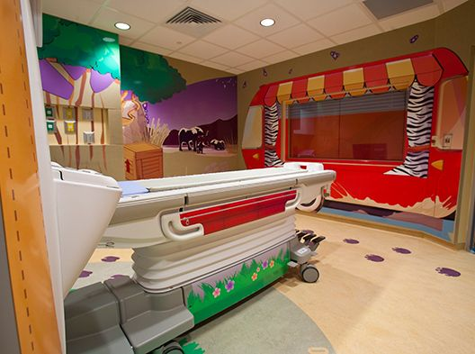


Background
GE Healthcare noticed that:
- Children were scared of MRI machines.
- Many needed sedation.
- High anxiety levels.

Problem
MRI machines were:
- Large
- Loud
- Intimidating
- Clinical and cold
Children felt like:
“Entering a scary tunnel.”

Design Thinking Process
Empathize
- Observed children before MRI.
- Interviewed parents.
- Spoke with nurses.
Define
“Children fear the MRI experience, not the technology.”
Ideate
- Turn MRI into adventure experience.
- Add themes (Pirate ship, Space journey).
- Storytelling concept.
Prototype
Redesigned room with themes.
Test
Children entered without fear.
Sedation rate dropped drastically.

Outcome
- Improved patient experience.
- Reduced hospital costs.
- Increased operational efficiency.

Discussion
- Did GE change the machine?
- Or did they redesign the experience?
- What role does empathy play in healthcare?

